Alloy analyzer is something I kind of give commands to, and it checks the logic of the software
Structural/behavioural modeling
Modeling is, I guess, an abstract description of some piece of software - conceptually what functions, classes etc. are in it and how they're supposed to work together
And in Alloy you can do this, and quickly and cheaply test what works and what doesn't

MIT, the 90s
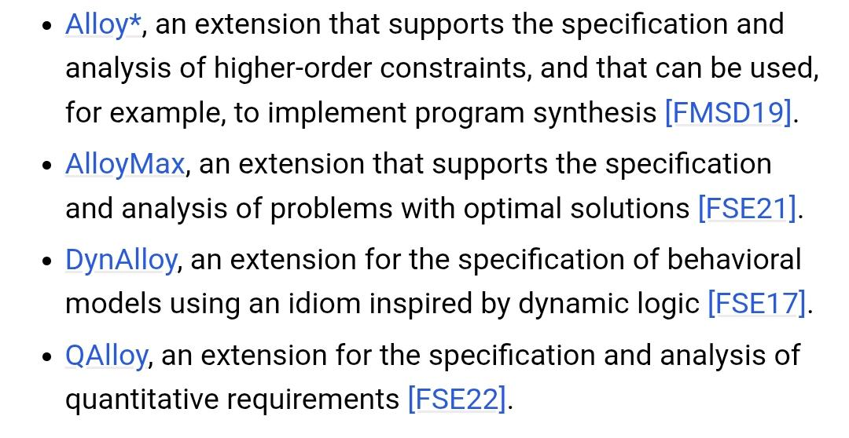
It has extensions

Basic definitions of the core concepts/terms:
Subset signatures - one atom belongs to several signatures at once (barely ever used)
Abstract signature - you can extend from it, but it can't be used on its own
Atom - the smallest unit in Alloy, the “object” that comes from a sig (sig Dir{} -> Dir0 <- atom)
Signature - a set of atoms
entries - the name of the relation (doesn't matter what it's called)
entries : set Entry sets up the connection from the sig we're writing this in, to Entry
Field - a relation between signatures
TL Signature - not an extension of anything
extension signature - a subset of another signature
Scope - determines the max number of atoms that will be generated
Entry, Dir and File are signature names
Entries is a field

Relational operators
. | Navigation
^ | All descendants
~ | d.entries (normal, entry [entries is a field with Entry] in dir); entries.e which Dir e is in  =>> Sig.field, atom.Field is normal navigation BACKWARDS it's then Field.atom  {the ~ is barely ever used, more just . with reversed logic}
-> | x -> e in entries, the pair (x, e)
sig > atom > field
Boolean operators:
not / !
and / &&
or / ||
implies / =>
iff <=>

quantifiers:
all x : Dir | For ALL atoms
some x : Dir | THERE EXISTS an atom
disj x, y | x and y are DISTINCT

Cardinality:
How many atoms are inside the set
Directory.thingy(field)

no | Does the directory have ZERO atoms in thingy?
some | Does the directory have AT LEAST ONE atom in thingy?
one | Does the directory have EXACTLY ONE atom in thingy?
lone | Does the directory have AT MOST ONE atom in thingy?

Multiplicity in declarations
For setting a rule using no, some, one, lone

lone entries.e - does e belong to entries in at most one directory?
Commands:
run - is this even possible, can this be done
check - statement -> try to disprove it
these commands are kept in some kind of history in the file
you start with an empty run to check that everything works
then you move on

fact
I use fact to define a condition that must always hold, the analyzer follows it
for example: Object in Dir + File, meaning atoms from Object must be EITHER in Dir OR File

assert
this is used to create a condition, which then gets put into check
// assert = a named claim
assert no_partitions {
all o : Object | reachable[o]
}

// check then verifies that assert
check no_partitions

-but it also works without it - you can write the condition straight into check instead of putting it in assert)

Set operators
& | intersection (what they have in common)
- | Difference, subtract the set

fun - returns a set
fun name [parameter : Sig] : return type { expression }
-I create the parameter here (name it, say, „o“)
Something gets applied to it, e.g. .^(entries.object) //all descendants
SO THIS GIVES ME SOME SET
and then we use pred for a true/false result
pred - returns true/false / it's possible / it's not possible
this calls a condition on atoms/a set of atoms
pred name [parameter : Sig] {expression}
here the expression checks that o is in root or in the set descendants[Root], and it gets named, say, reachable
-so basically either root or inside root

Structural modeling
Signature declaration
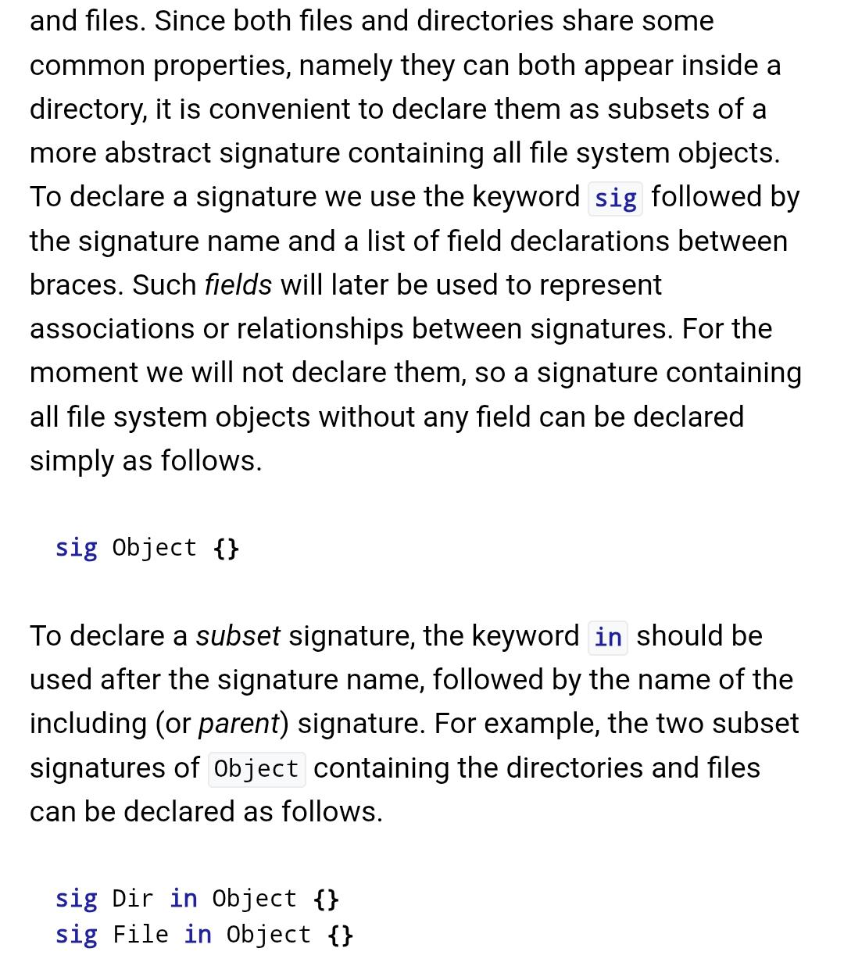
The whole code file is called a Domain (I think)

A distinguishing feature of Alloy is that commands can be included together with the declarations and constraints in a model.
(I don't get it)
-I understand it as: in one file I have both the sig and then also some definitions, like for example that a file always has a unique name, and normally that would be in separate files

The parts of the code are called atoms, basically those pieces of code only depend on each other through the relations they have between them (relations)

isomorphic atoms - when it's given that person1 is a friend of person2, then the reverse is technically a different declaration but the same one, and the analyzer treats it as one
if you hit 'new', it won't just state the same thing with the tag swapped, it'll say that person2 is friend of person0, in a cycle (no idea why that's relevant)
meaning the names don't just get randomly reassigned, both versions get printed out
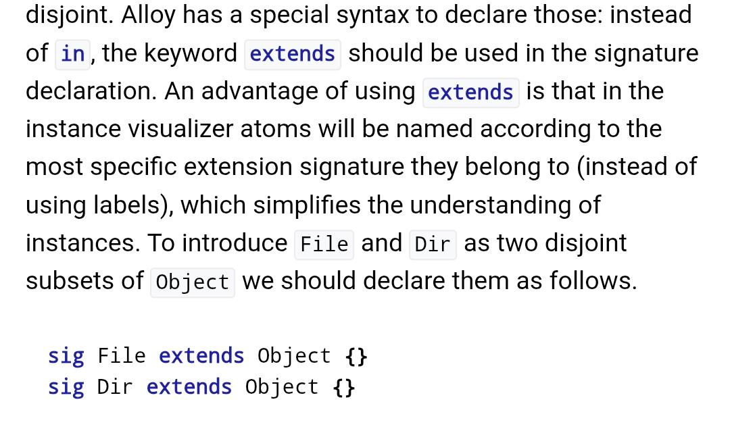
extension of a top level signature
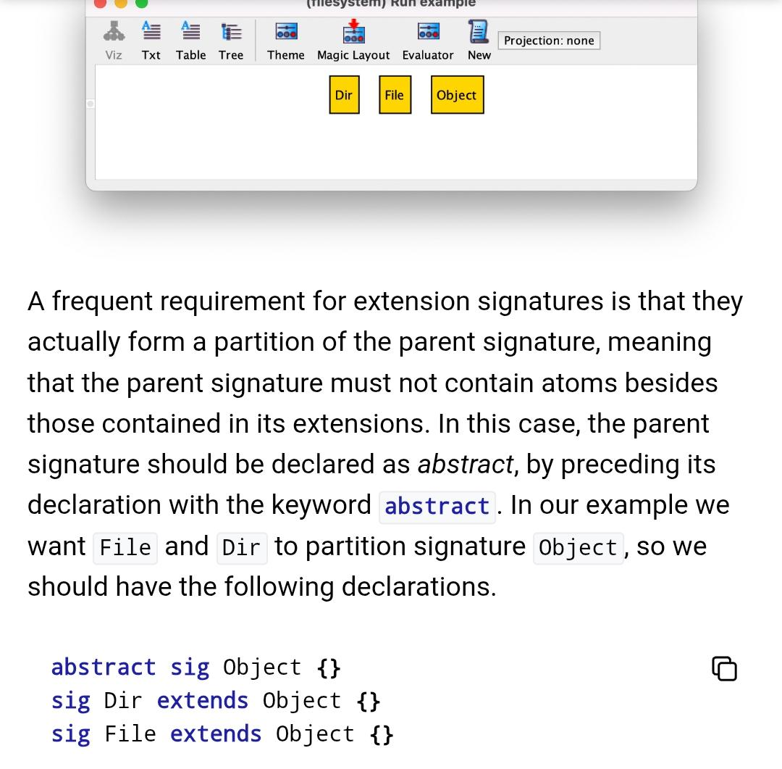
you can't make constants, just simply name something, but we can limit how many
individual instances there are
I can have one thing named with multiple names (that's called a hard link)
when I have one sig Root extends Dir {}, Root already has scope 1

one sig Root extends Dir {}

it just makes a single root, no root0,1,2,...

Field declaration
Signatures just define that something exists
Fields define relations between atoms
Sig Dir extends Object {
Entries : set Entry
}
-Inside Dir there's Entry
So Dir owns Entries
Field multiplicity determines how many relations an object has, e.g. how many Entries a dir has

Subset signatures(⊆ - subset)

Just like you have relations between numbers x and y (<;>;=;...), this is a relation too, just for a single element (the evenness of a number, for example)
In the table, this is recursion (a discussion forum: posts > a post replies to a post)

Extended [signatures] can't share an atom, disjoint - ensures that for a signature there's an atom that doesn't belong to more signatures
subsets can share an atom, for example Dir is a subset of Object
Basically when I want to mark something but not necessarily everything, and you can also make a Field out of it

Multiple inheritance
Alloy can't do that
So to get around this, you make signatures “a,b,c” in whatever you're inheriting from
sig Shape in Tag {}
sig Label in Tag {}
sig Alert in Tag {}

With this I get the following: Then I say: Alert = Shape & Label
[Alert ⊆ Shape ∩ Label]
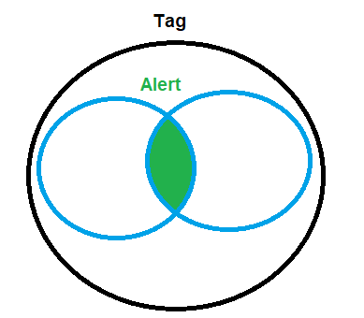
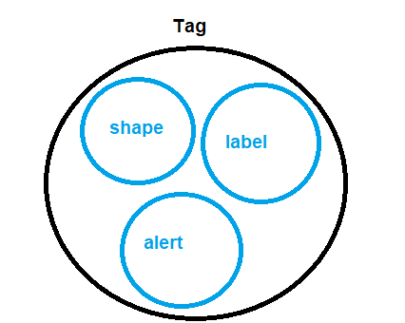
Enumeration signatures

Enumeration signature
A set of predefined values (the set 1; 8; 63)
I make such a set like this:
Enum Name { thing1, thing2, thing3}
Which creates the set Name = {thing1; thing2, thing3}
If I do, say
In the sig definition I can then define -> name : one Name, so all the atoms in it must have thing1/2/3
So I do: Atom0.name = thing2,...

“Commands+”
You can do this
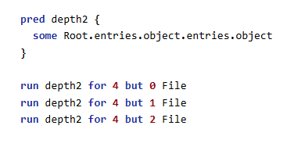
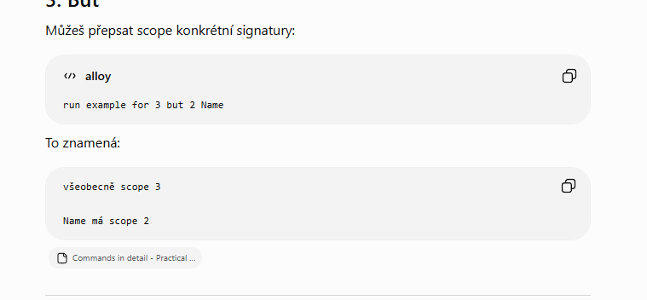
-If I already have one sig, I can't change the scope like this
-if I define object 3 and file3, dir3, that logically doesn't work because dir is an instance of object, so there'd have to be 6 objects
-if I have File some somewhere, but I use up the whole scope on Dir, it complains

--- ---- add the remaining advanced topics ---- ---
Behavioral modeling
Structural modeling was about static things, here time gets added to it.

Transition System
States of objects

They're determined implicitly, for example I just make a rule (fact) that says something has 0 atoms, and that's then effectively the first state
Concepts: var - an object marked like this can change with states
For example:

sig Token {}
sig File
{
var shared : set Token // changes
}

var sig uploaded in File {}

var sig trashed in uploaded {}
I have a set of tokens, a file refers to an arbitrary number of tokens, which is fixed though, so every File atom has a set of tokens of an unspecified size, thanks to “var” the number of Token atoms assigned to a File can change depending on the state
And inside File there's uploaded, and inside uploaded there's trashed (mutable - changeable)
so trashed is also a file, but it's a subdomain within the uploaded domain, which contains all the uploaded Files

Initial state:
Fact init { no uploaded
no shared}
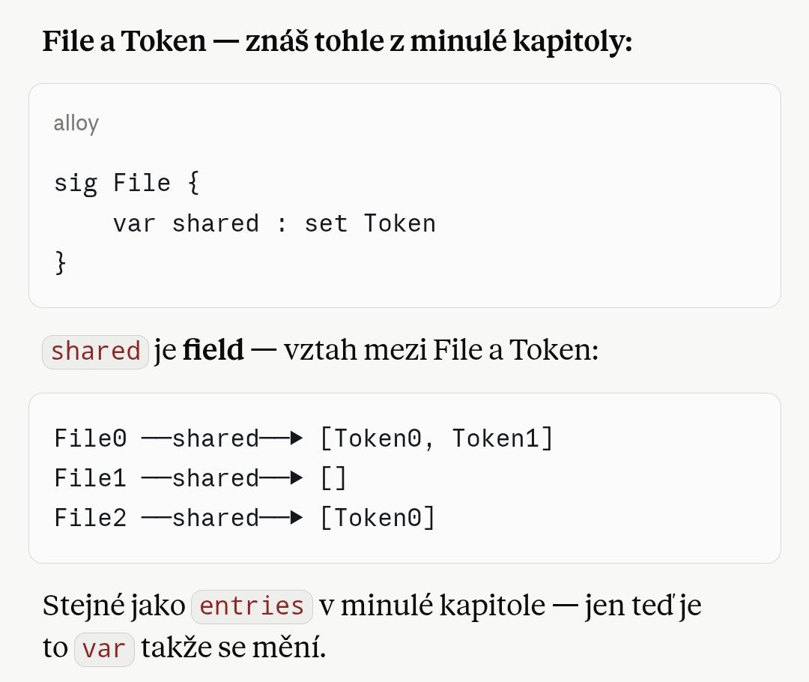
This rule makes it so init has no atoms in it

Purpose of tokens:
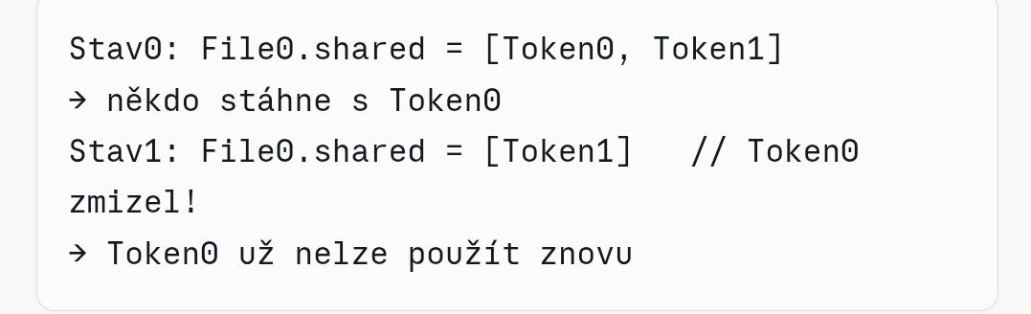

fact transitions {
always (
(some f : File | upload[f] or delete[f] or restore[f]) or
(some f : File, t : Token | share[f, t]) or
(some t : Token | download[t]) or
empty
)
}
Always says that something must hold in every state
Eventually says that it's possible
These two things are “operators of linear time temporal logic” and they determine what's supposed to happen in each state

Some - some atom gets picked
| - carry out [an action] on the atom
Or - or perform [an action] on the atom
Some „f“ atom from File, which(|) is in uploaded/restored/delete

Specifying actions
Here I'm actually using pred
pred upload [f : File] {
f not in uploaded // GUARD = „f is not yet in uploaded“
uploaded' = uploaded + f // EFFECT = „add f to uploaded“
}
This says that atom f, a file which isn't in the uploaded subset, will get added to the uploaded subset

Stutter
-if nothing happened, the system waits
pred stutter {
uploaded' = uploaded
trashed' = trashed
shared' = shared
}
It gets added after empty as: “ or stutter”

Validating the design
Before this, we just ran an empty run as a check, which told us whether all the facts were satisfied. NOW I can, for instance, click new config, and that gives me a larger number of atoms
New trace again, with the same atoms, creates a different sequence of actions(I don't get it)
New init changes the initial state, which probably doesn't work here (in this design of the data-sharing app)
New Fork - for a given state, a different state gets chosen than would otherwise be there

Verifying the expected properties

